**Essentials of Industrial Hygiene, 1st Edition**

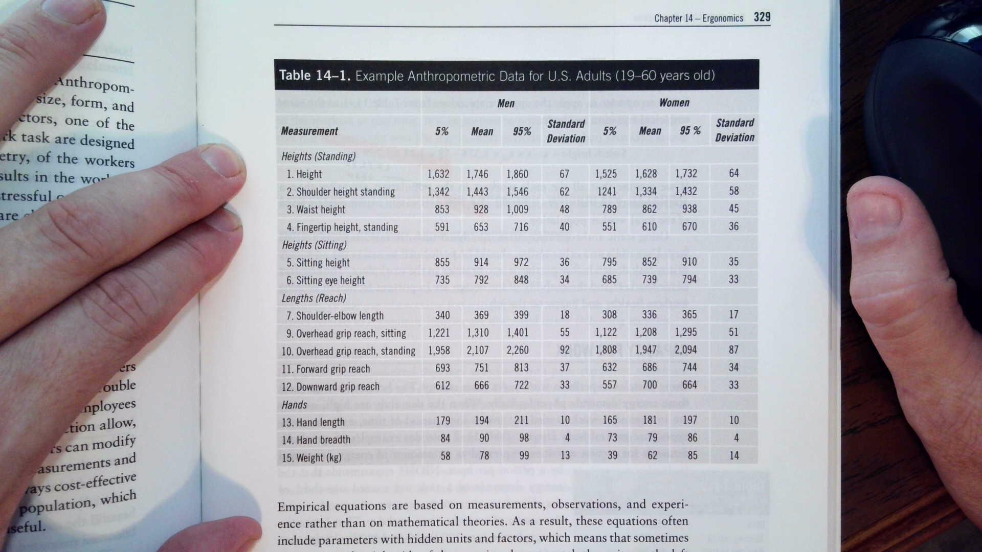

**Equation Sheet**



C = Concentration (ppm, mg/m3)

T = Time (minutes)

**Chapter 6 Gasses and Vapors**

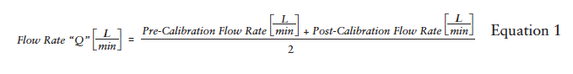

Normal Temperature and Pressure (NTP)

25˚C and 760 mmHg

At NTP, 1 mole of any gas will occupy 24.45 L

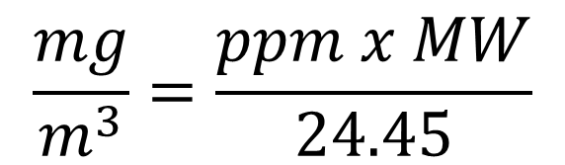

$$ppm= \frac{(\frac{mg}{m^{3}})(24.45 L)}{(molecular weight)}$$

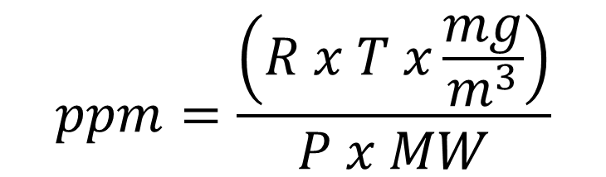

$$ppm= \frac{Vcontaminant}{Vair} ×{10}^{6}$$

Ideal Gas Law

$$PV = nRT$$

Generalized Gas Law

$$\frac{P_{1}V_{1}}{T_{1}}=\frac{P_{2}V_{2}}{T_{2}}$$

Charles’ Law

$$\frac{V_{1}}{T_{1}}=\frac{P_{2}}{T_{2}}$$

Boyle’s Law

$$P_{1}V_{1}=P_{2}V_{2}$$

Sampling Duration

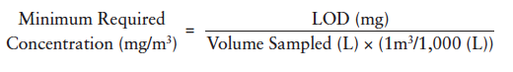

**Chapter 7 Aerosols**

Air Sampling Pump Calibration

Correction for Temperature and Pressure

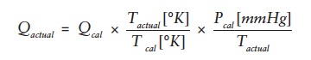

**Chapter 8 – Ventilation**

Volumetric Flow Rate

Q = VA

Where:

Q = Volumetric air-flow rate, in cubic feet per minute

V = Average velocity, in feet per minute

A = Duct cross-sectional area, in square feet

Airflow in a duct

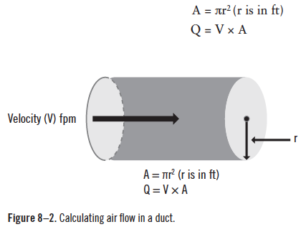

Duct Pressure Balance

TP = VP + SP

Where:

TP = Total Pressure

VP = Velocity Pressure

SP = Static Pressure

Velocity of Air Flow in a Duct



Capture Velocity

Q = VA

A = 4πX2

V = Q/(4πX2)

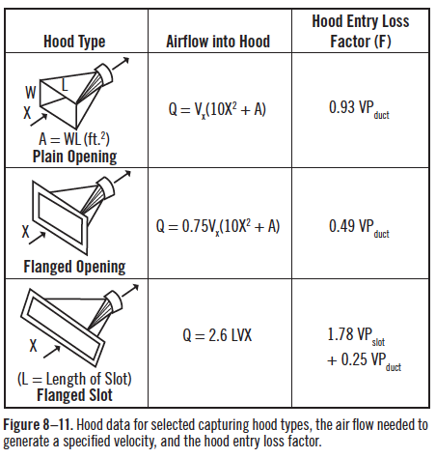

Fan Speed and Flow Rate

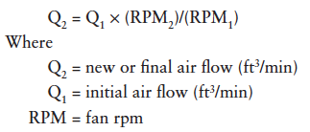

Fan Speed and Fan Static Pressure

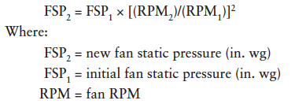

Fan Speeds and Horse Power

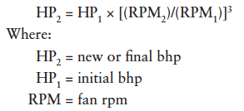

General Ventilation

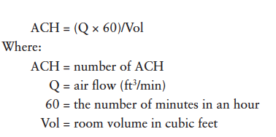

**Chapter 9 – Respiratory Protection**

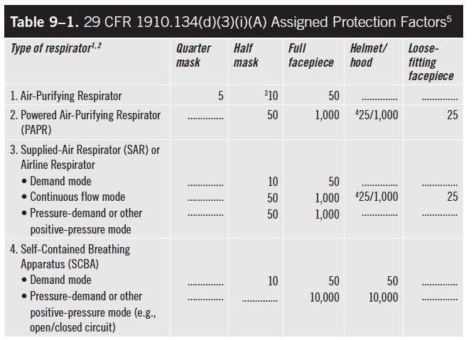

MUC= APF x OEL

Where:

MUC = Maximum Use Concentration

APF = Assigned Protection Factor

OEL = Occupational Exposure Limit

**Chapter 11 – Noise**

*λ* = c/f

Where

f = frequency

*λ =* wavelength

c = speed of sound

Speed of sound in air at 25˚C = 346.06 m/s

Sound Pressure Levels

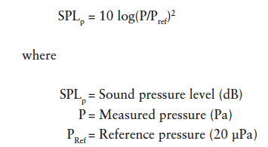

Sound Power Level

Lw = 10 log(Pac/Pac˚)

Where

Lw = Sound Intensity Level (dBSWL)

Pac = Measures acoustic power (W)

Pac˚ = Reference acoustic power (1E-12W)

Sound Intensity Level

Total Noise from Multiple Sources

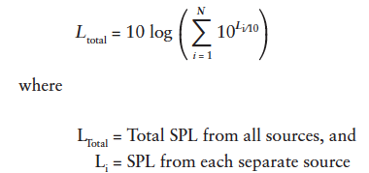

Calculating Daily Noise Dose

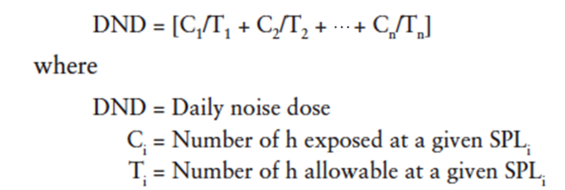

Allowable Duration for a Given Noise Level



Blade Noise Frequency

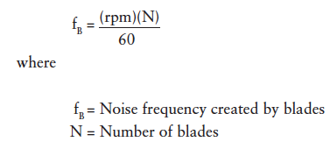

Using Distance to Reduce Noise Levels

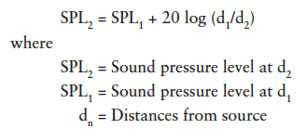

Using Barriers to Reduce Noise Levels (cont.)

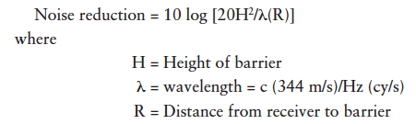

NIOSH estimated noise exposure when using hearing protection devices (plugs or muffs)

Single Protection:

If C-weighted use: Estimated Exposure (dBA) = TWA (dBC) - [NRR x 50%], or

If A-weighted use: Estimated Exposure (dBA) = TWA (dBA) - [(NRR - 7) x 50%]

Dual Protection:

If C-weighted use: Estimated Exposure (dBA) = TWA (dBC) - [(NRRh x 50%) + 5], or

If A-weighted use: Estimated Exposure (dBA) = TWA (dBA) - {[(NRRh - 7) x 50%] + 5}

**Chapter 12 – Radiation**

Frequency and Wavelength

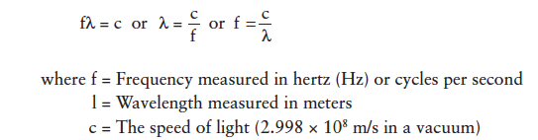

Inverse-Square Law

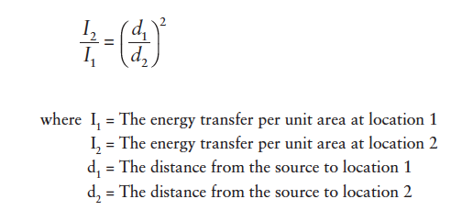

Radioactive Decay

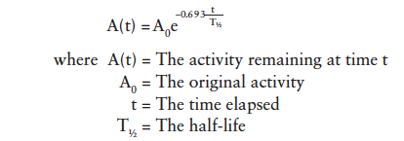

Effective Half-life

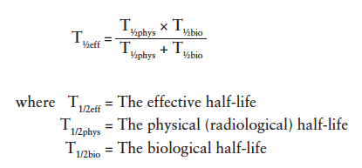

UV Radiation Dose

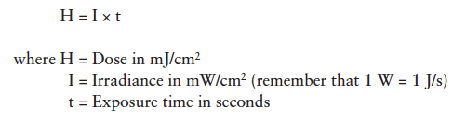

Near Field, Far Field Boundary

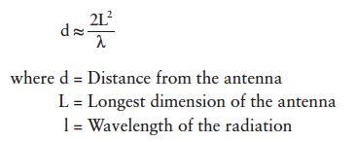

Microwave Power Density

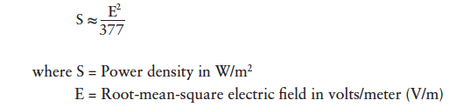

**Chapter 13 – Thermal Stressors**

See end of document for Psychometric Chart and Windchill Index Chart

Temperature Conversions

˚F =((9/5)*˚C)+32

˚C = (5/9)(˚F-32)

K = ˚C + 273.15

Thermal Balance

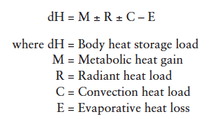

Where

Metabolic heat production (physical activity; W, kcal/h)

Air temperature (°C, °F)

Water vapor pressure in air (Pa, mmHg)

Wind speed (m/s, ft/min)

Mean radiant temperature (tr; °C, °F)

Type of clothing (Clo)

1 kcal/hr = 1.163 W

1 BTU/hr = 0.2931W

Vapor Pressure of Water (Antoine equation)

PvH20 = 10^(8.07131-(1730.63/(233.426+T)))

Where:

PvH20 is in mmHg

T is in Celsius

Note: mmHg / 7.5 = kPa

Heat of Vaporization of Water

2,260 kJ/L or

540 kcal/L

Note: 1 W = 1 J/s

Maximum recommended sweat rate

Un-Acclimated worker 0.625 L/h

Acclimated worker 1.00 L/h

Body Surface Area (BSA)

BSA (m2) = √[[(height (cm) x weight (kg)]/3600]

Standard Worker BSA = 1.8 m^2

Mean Radiant Temperature

tr = tg + (1.8xV^0.5)(tg-ta)

Where:

tr = mean radiant temperature (C)

ta = ambient temperature from dry bulb (C)

tg = globe temperature (C)

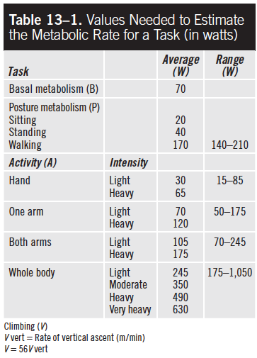

Radiant Heat Exchange (R)

Clothed worker heat gain: R = 4.4(tr – tsk)

Unclothed worker heat gain: R = 7.3(tr – tsk)

Convection Heat Exchange (C)

Clothed worker heat gain: C = 4.6V0.6(ta– tsk)

Unclothed worker heat gain: C = 7.6V0.6(ta– tsk)

Evaporative Heat Loss (E)

Clothed worker heat loss: Emax = 7.0V0.6(Psk – Pa)

Unclothed worker heat loss: Emax = 11.7V0.6(Psk – Pa)

Thermal Stress Evaluation

WBGT values (°C or °F) are calculated using the following equations:

(1) Outdoors with solar load

WBGT = 0.7tnw + 2tg + 0.1ta

(2) Indoors or outdoors with no solar load

WBGT = 0.7tnw + 0.3tg

Where tnw = Natural wet-bulb temperature (°C or °F)

Physiological Monitoring

HR increase capacity (CHR) is defined by the following:

CHR = 40% × (220 – Age) + 60% × Resting HR

Body temperature

Adjusted maximum rate = 0.7 × (220 – Age)

**Chapter 14 – Ergonomics**

Design for Clearance

Clearance = x + s * z90

Where:

x = Population average/mean stature

s = Population standard deviation

z90 = Empirically derived safety factor = 1.28

Design for Reach

Reach = x – s * z10

Where:

x = Population average/mean reach

s = Population standard deviation

z90 = Empirically derived safety factor = 1.28

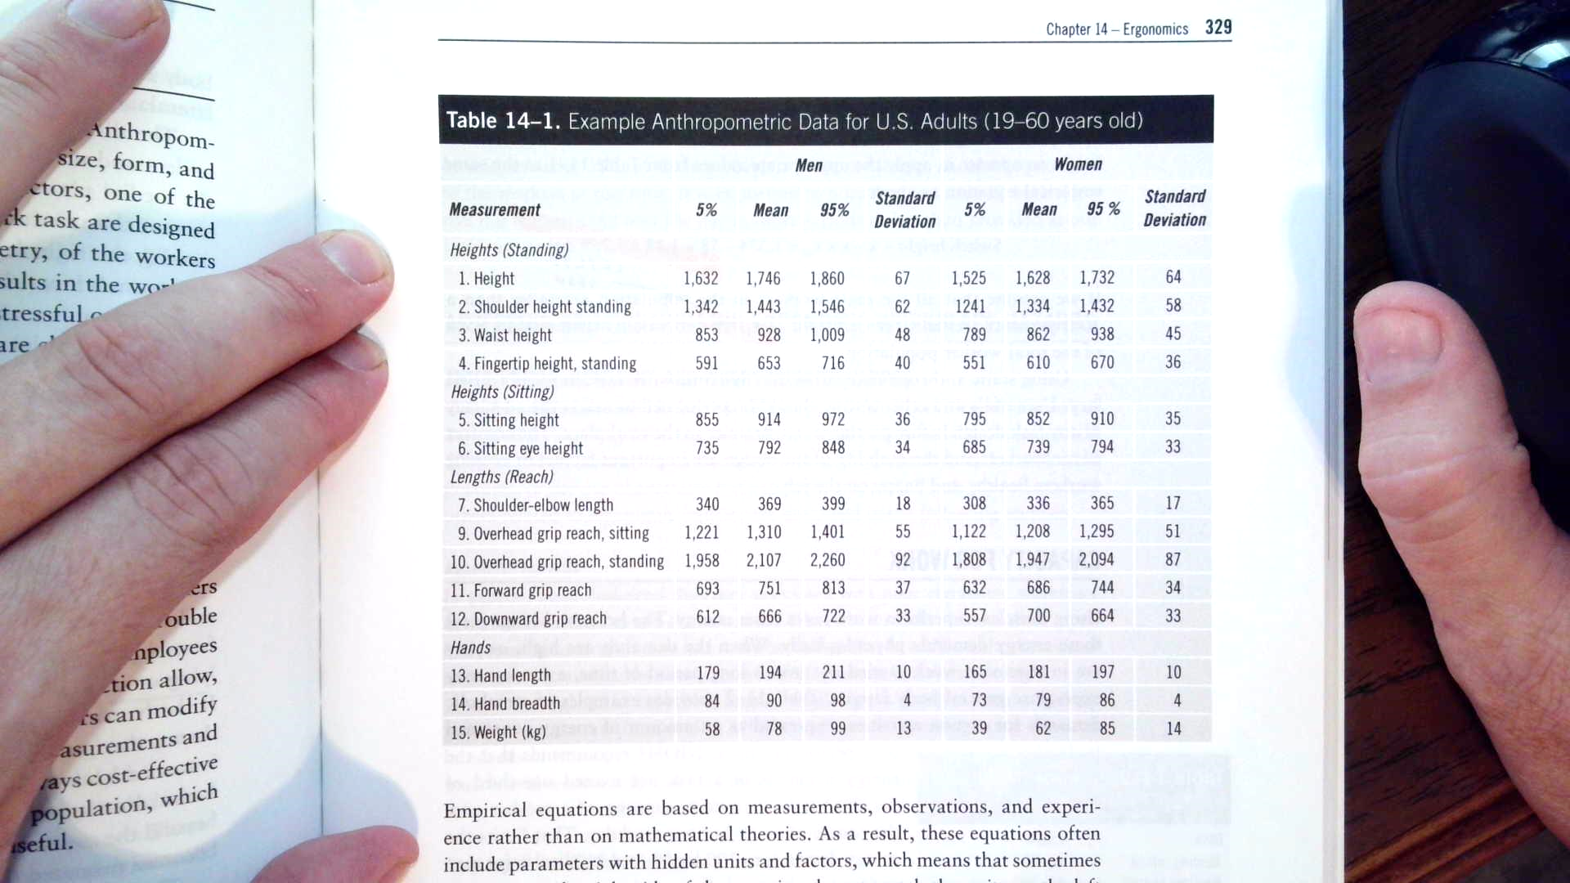

Capacity for Work



Where Capacity = 300 kcal/h for men and 210 kcal/h for women.

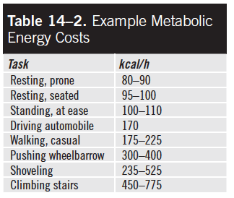

Recommended Weight Limits (RWLs)



